K. Ruthwik Bhat 2403A51L08 B-51

Lab 1.5: AI-Assisted Coding using GitHub Copilot

Task 0: Environment Setup

Steps:
- Install Visual Studio Code
- Open VS Code → Extensions
- Search GitHub Copilot
- Click Install
- Sign in with GitHub account
- Enable Copilot suggestions
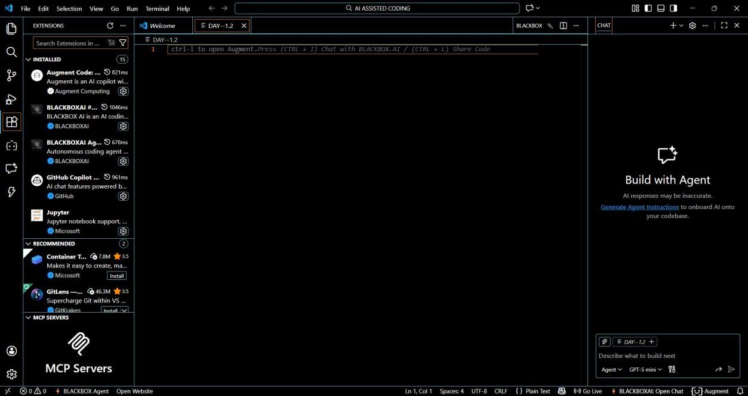

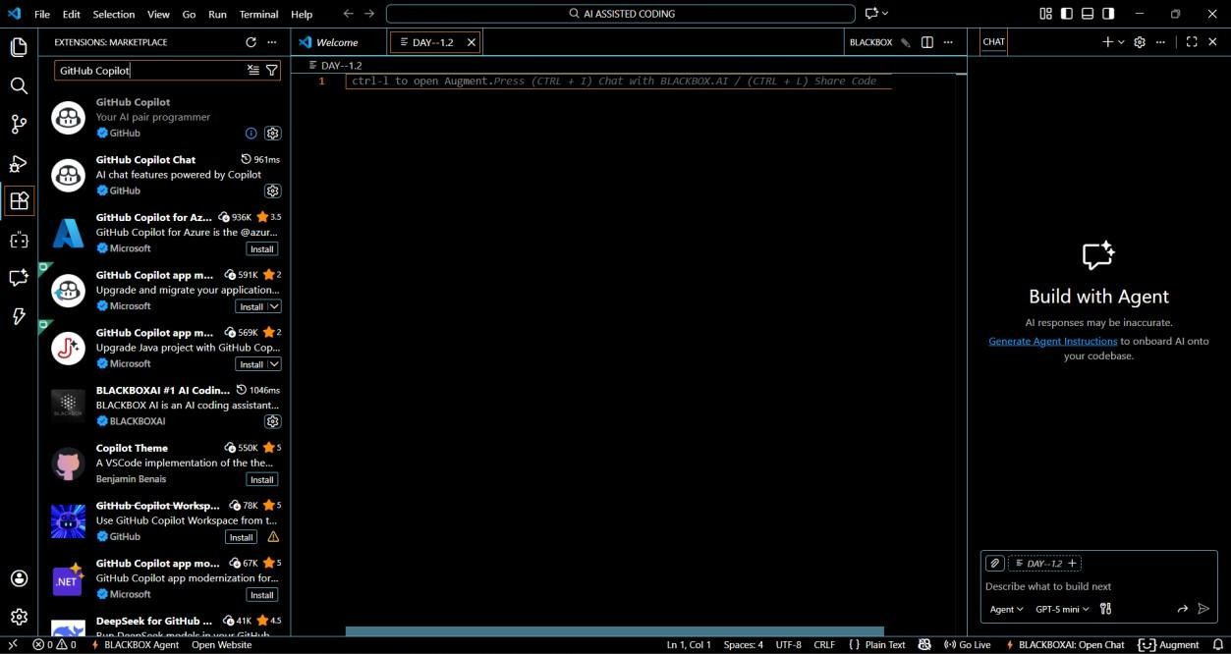
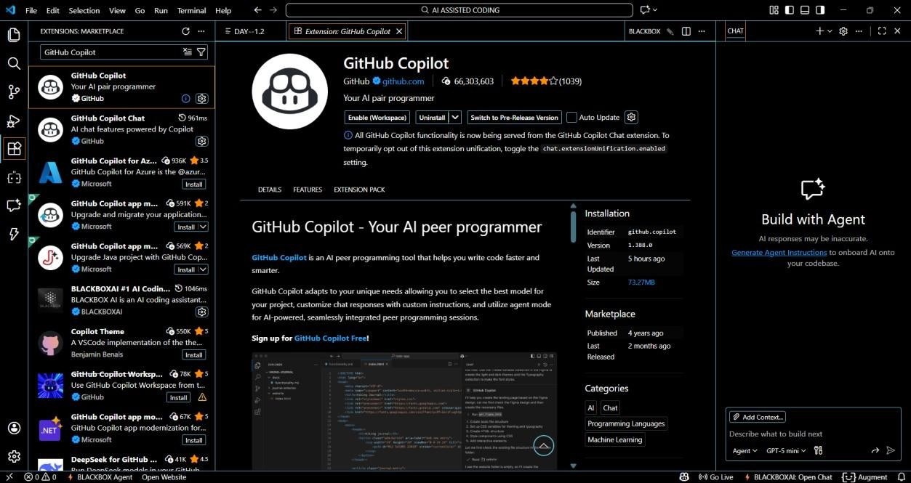
Explanation: GitHub Copilot was installed and configured in Visual
Studio Code by signing in with a GitHub account. This enables AI-based code suggestions directly inside the editor, helping developers write code faster and more efficiently.

Task 1: String Reversal Without Functions

Prompt:
# Write a Python program that accepts a string from the user # Reverse the string using a loop

# Do not use any user-defined functions # Print the reversed string
###CODE:
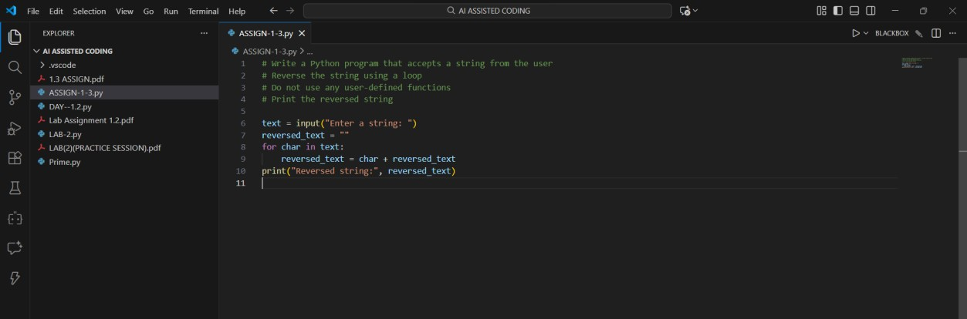
### OUTPUT:
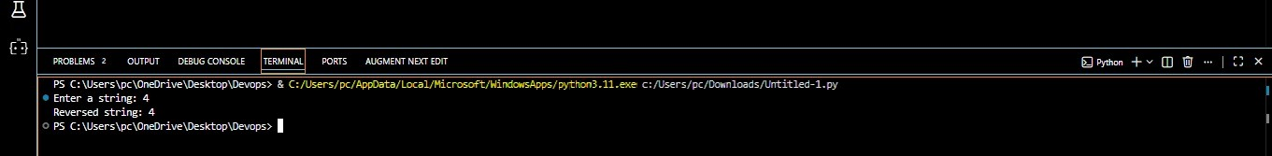
Explanation: In this task, GitHub Copilot generated Python code to reverse a string using a loop without defining any functions. The logic was written directly in the main program, demonstrating basic procedural programming.

Task 2: Code Optimization s Readability

Prompt:
# Simplify this string reversal code # Remove unnecessary variables
# Improve readability and efficiency
###CODE:

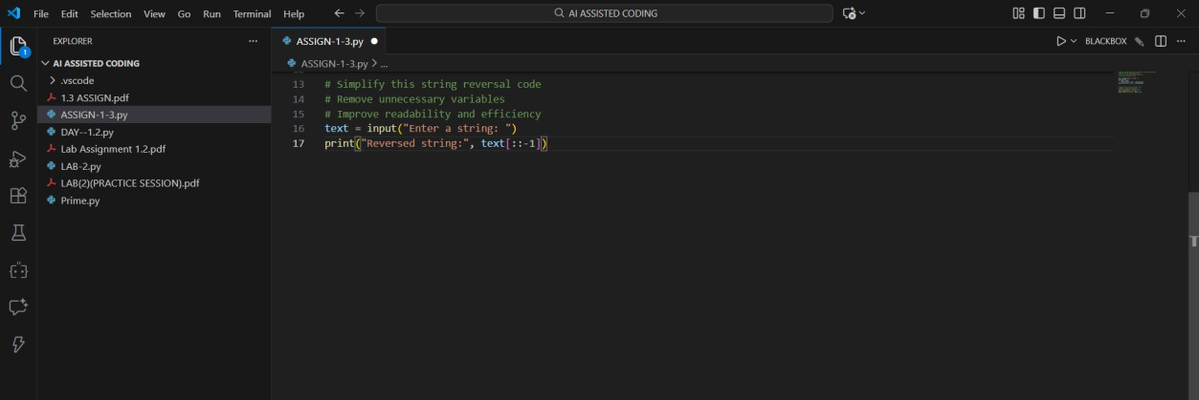
### OUTPUT:
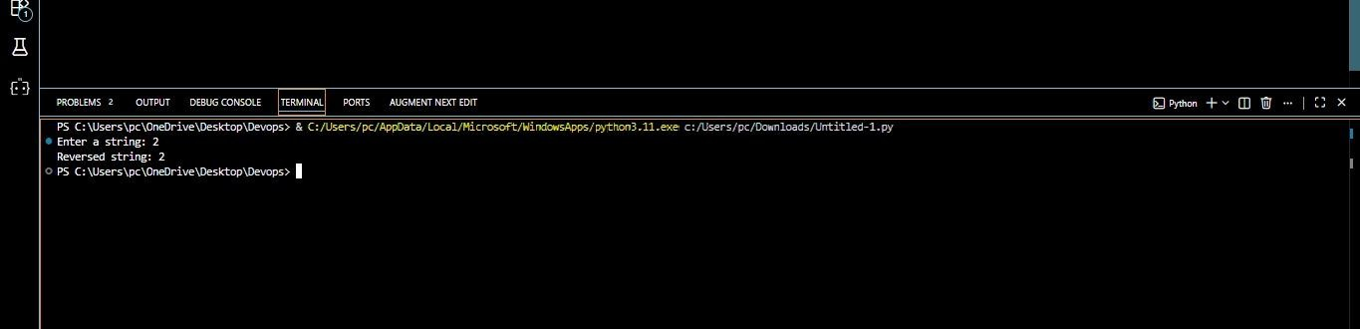
Explanation: The Copilot-generated code was optimized by simplifying the logic and removing unnecessary variables. The improved version produces the same output with better readability and reduced code complexity.

Task 3: String Reversal Using Functions

Prompt:
# Write a Python program using a function to reverse a string # The function should return the reversed string
# Add meaningful comments
###CODE:

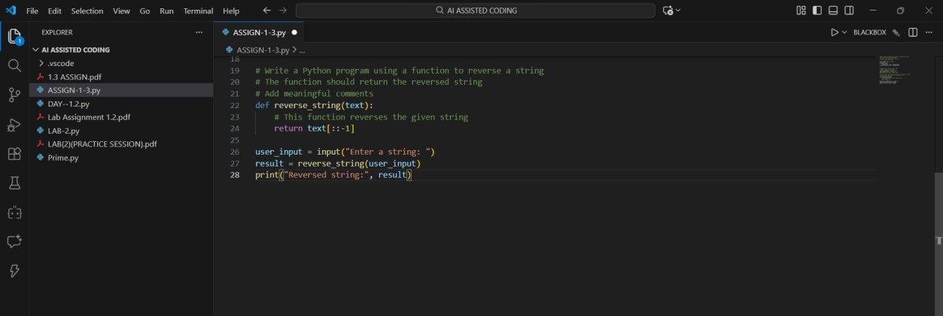
### OUTPUT:
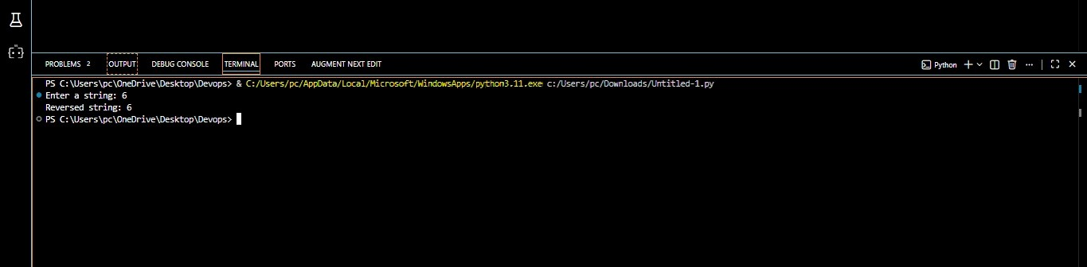
Explanation: GitHub Copilot was used to create a modular program using a user-defined function to reverse a string. This approach improves reusability, clarity, and makes the code easier to maintain.

Task 4: Procedural vs Modular Comparison

Step 1: Prompt:
# Compare string reversal programs with and without functions # Discuss clarity, reusability, debugging, and scalability
Step 2: Answer (Analysis Output)

Feature Without Function
With Function

Code clarity Medium High
Reusability Low High
Debugging Difficult Easy Large applications Not suitable Suitable

Explanation: A comparison was made between function-based and non- function-based programs. The analysis shows that modular code is more reusable, easier to debug, and better suited for large-scale applications.

Task 5: Loop vs Built-in Reversal

Step 1: Loop-Based Prompt
# Write a Python program to reverse a string using a loop # Do not use slicing or built-in methods
###CODE:
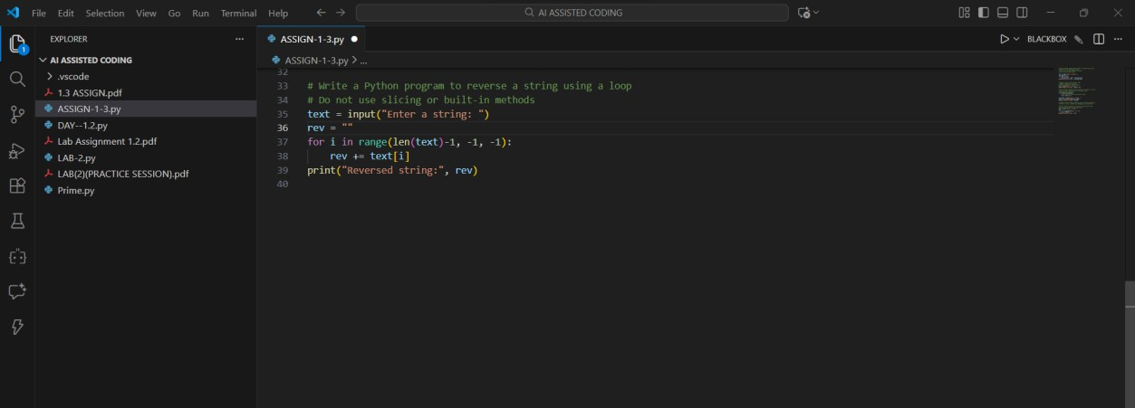
### OUTPUT:

Step 2: Built-in Prompt
# Write a Python program to reverse a string using slicing
###CODE:

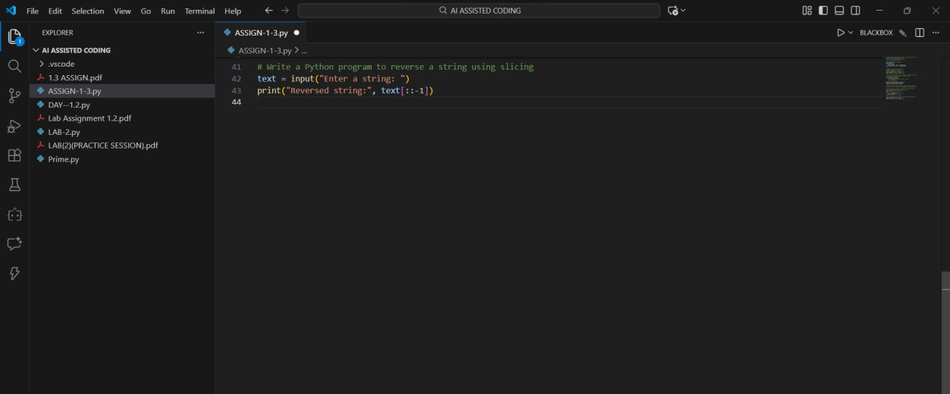
### OUTPUT:
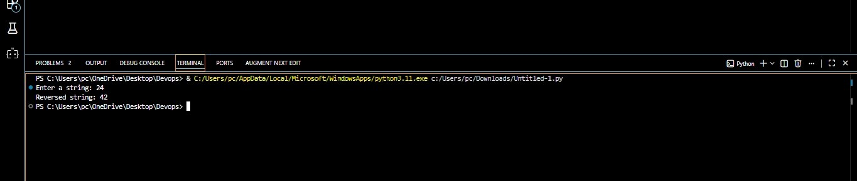
Explanation: Two different string reversal approaches were generated using Copilot: loop-based and built-in slicing. Both methods have the same time complexity, but the built-in approach is more concise and readable.

